24.78: a) For a normal spherical capacitor: 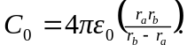 Here we have, in effect, two parallel capacitors, 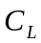 and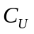.
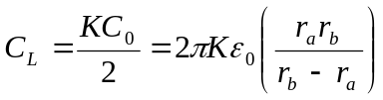and 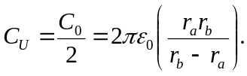
b) Using a hemispherical Gaussian surface for each respective half:
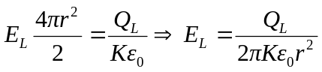 and 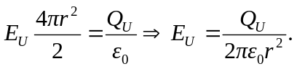
But 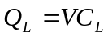 and 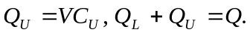
So: 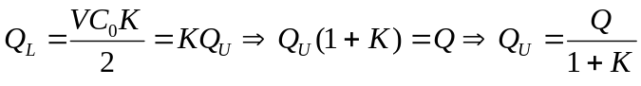and 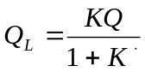.
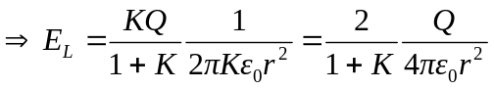and 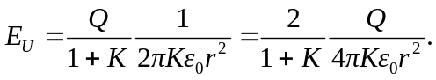
c) The free charge density on upper and lower hemispheres are:
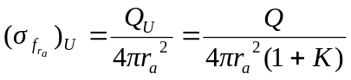and 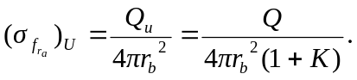
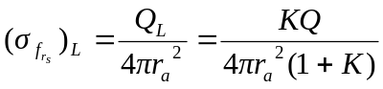and 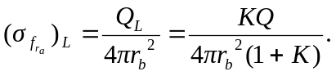
d) 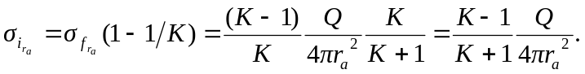
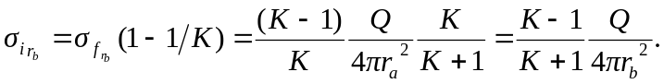
e) There is zero bound charge on the flat surface of the dielectric-air interface, or else that would imply a circumferential electric field, or that the electric field changed as we went around the sphere.

